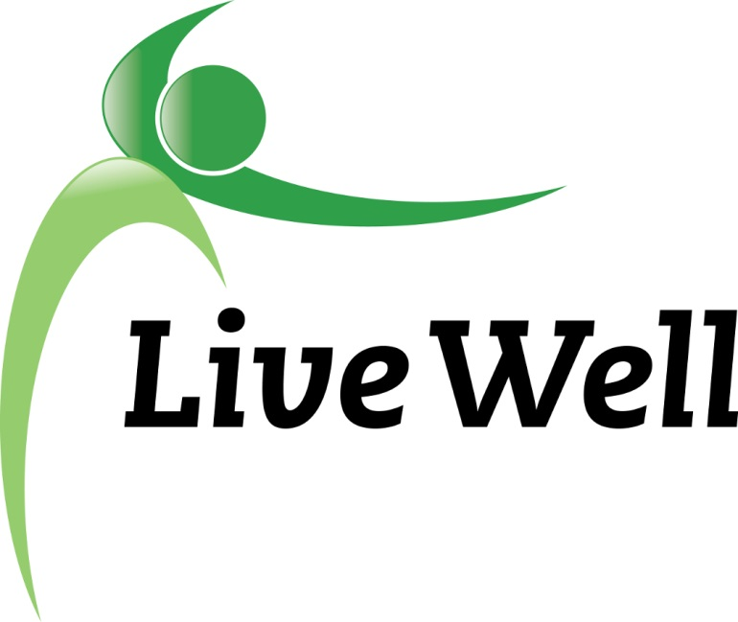
Healthy Food For All

Work Group

Friday, October 31, 2014
10:00 – 11:30 a.m.

Community Health Facility

200 Maine Street, Lawrence

Second Floor Meeting Room AB

